Topic: (What is this piece of work about?)
Context: (Briefly describe the context for this piece of work?)
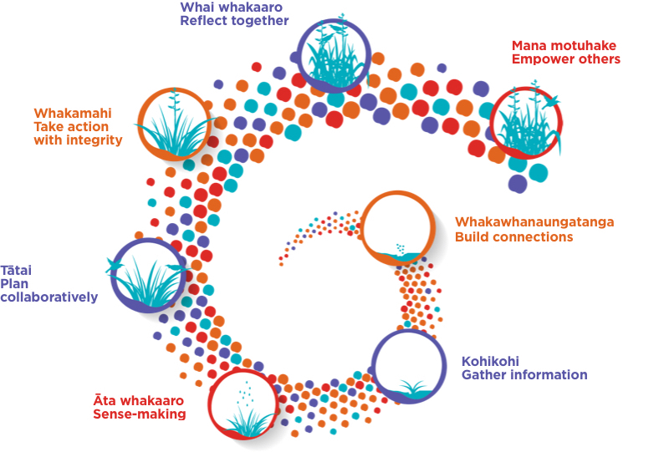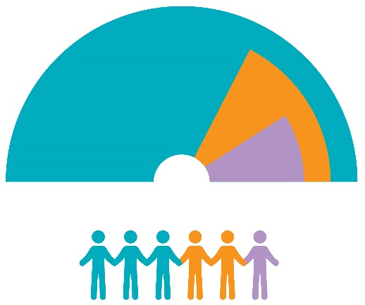

Describe your work: He Pikorua in Action and the Tiered Support Model.
He Pikorua in Action | Brief description | Resources / tools
Whakawhanaungatanga | How did you build connections? | Websites/links/PDFs/videos
Kohikohi / Āta whakaaro | What did you and the team do to gather information and draw conclusions? | Websites/links/PDFs/videos
Tātai / Whakamahi | How was the plan developed and put into action? | Websites/links/PDFs/videos
Whai whakaaro / Mana motuhake | What did you and the team learn? What are the implications for future work? | Websites/links/PDFs/videos
Use the other reflective questions on Te Rourou to help your kōrero.
He Pikorua in Action | Brief description | Resources / tools
Whakawhanaungatanga
Kohikohi / Āta whakaaro
Tātai / Whakamahi
Whai whakaaro / Mana motuhake

Before sending check:
- Is the information anonymised to ensure that any personal and identifiable detail is removed? (ākonga, whānau, kaiako, support staff, other educators, learning settings, local communities)
- Is the example aligned with:
  - The principles of the National Curricula?
  - The principles of Ka Hikitia?
  - The principles of He Pikorua?
  - The Teaching Council codes and standards?
- Is the example relevant and appropriate to the role of LSC?
- Are the tools/resources accessible to other LSC?

Please note that the moderator of the site will contact you with a final version of this example before posting it on the Spotlight on practice page.

